KKAO -

Functionality
The WIP calculation function valuates the unfinished products (work in process).
In the Product Cost by Period component, work in process is valuated at target costs. The operation quantities confirmed for the manufacturing orders or production versions (only in repetitive manufacturing) that are not scrap are valuated at target cost in accordance with the valuation variant for work in process and scrap.
You calculate work in process at target costs for the following objects:
- Product cost collectors
- Production orders with quantity structure assigned to the product cost collectors
- Process orders assigned to the product cost collectors

Scenario
As part of the period end processing Work In Process needs to be calculated for accurate period end closing.

Requirements
Partial or complete goods receipts was performed.

Menu Path | Accounting → Controlling → Product Cost Controlling → Cost Object Controlling → Product Cost by Period → Period-End Closing → Single Functions: Product Cost Collector → Work in Process → Collective Processing → KKAO - Calculate
Transaction Code | KKAO

1. Double click on KKAO – Calculate.

Calculate Work in Process: Collective Processing

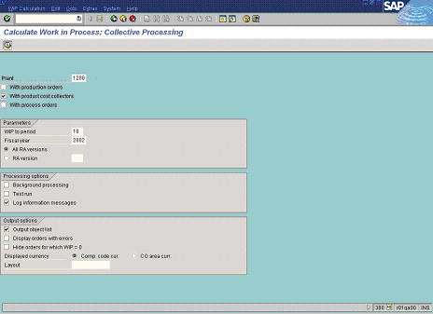

2. Update the following fields:

Field Name | Field Description | Values
Plant | Code identifying the operational unit of the company where the material is manufactured and stored | Example: 1200
WIP to period | Number identifying a fiscal month to which cumulative WIP will be calculated. | Example: 10
Fiscal year | Fiscal year for which you calculate variance. | Example: 2002
3. Click the With production orders checkbox to deselect.

4. Click the With process orders checkbox to deselect.

5. Click the All RA versions radio button.

6. Click the Test run checkbox to deselect.

7. Click the Log information messages checkbox to select.

8. Click the Execute button.

Calculate Work in Process: Object List

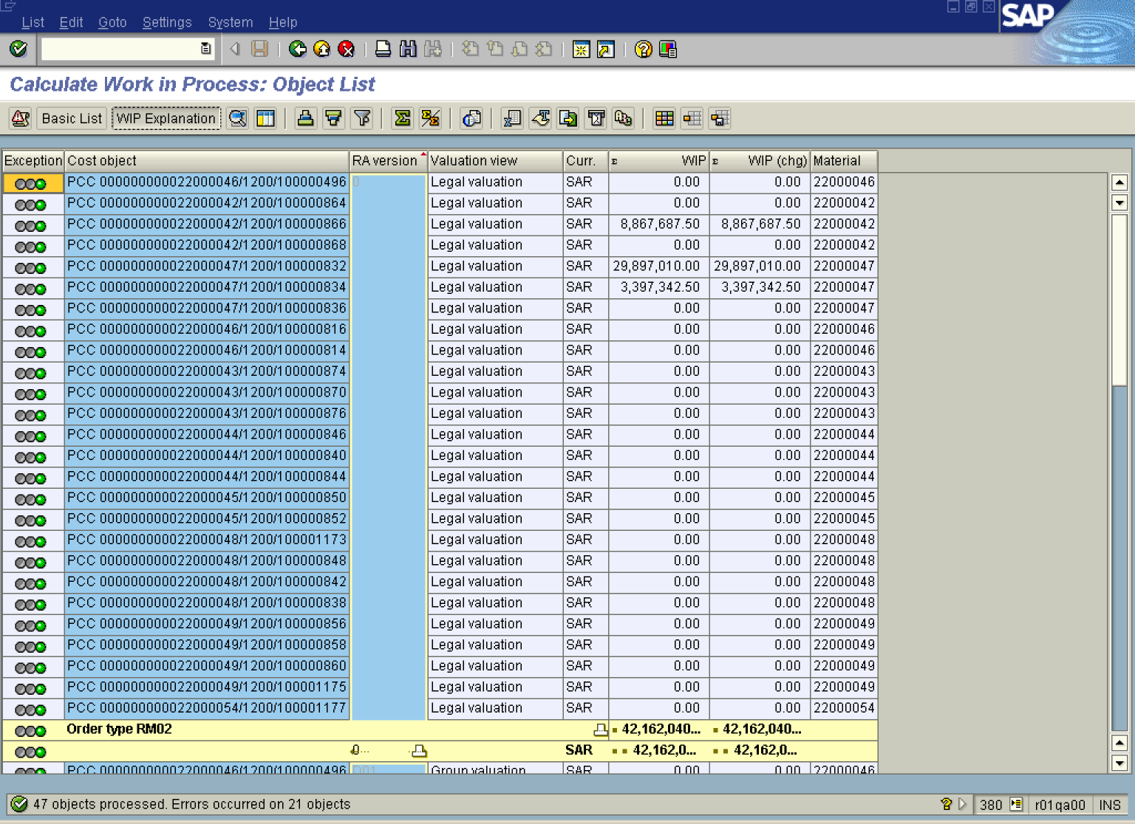

9. Select relevant line and click the WIP Explanation button.

Determine WIP: Explanation

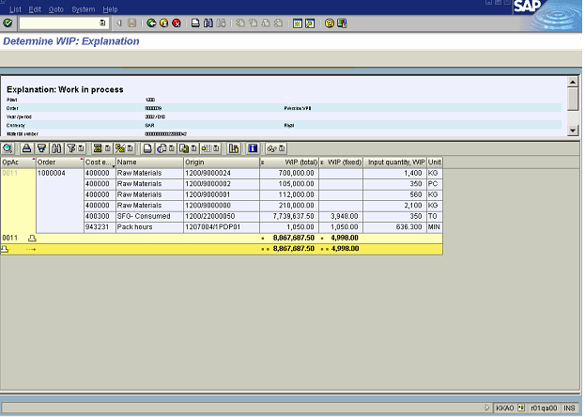

10. Click the Back button.

Calculate Work in Process: Object List

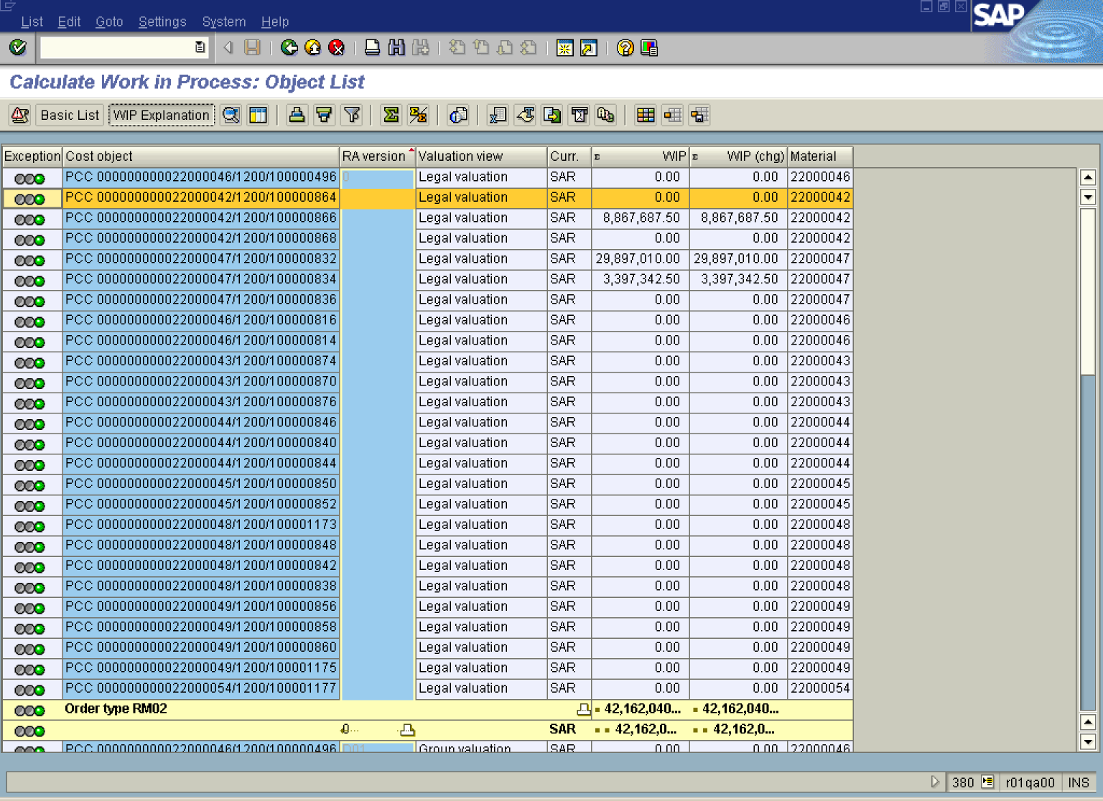

11. Click the Back button.

Exit list

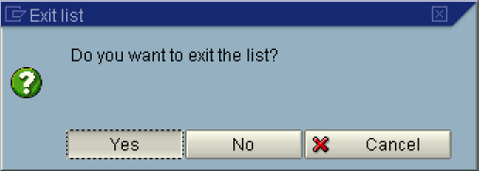

12. Click the Yes button.

